**Create and populate Dimension of TIME DW – Layer**

Task 01 CREATE DW.T_DAYS

Table T_DAYS was created by running command (attached file T_DAYS.sql). The result of command execution is presented below.

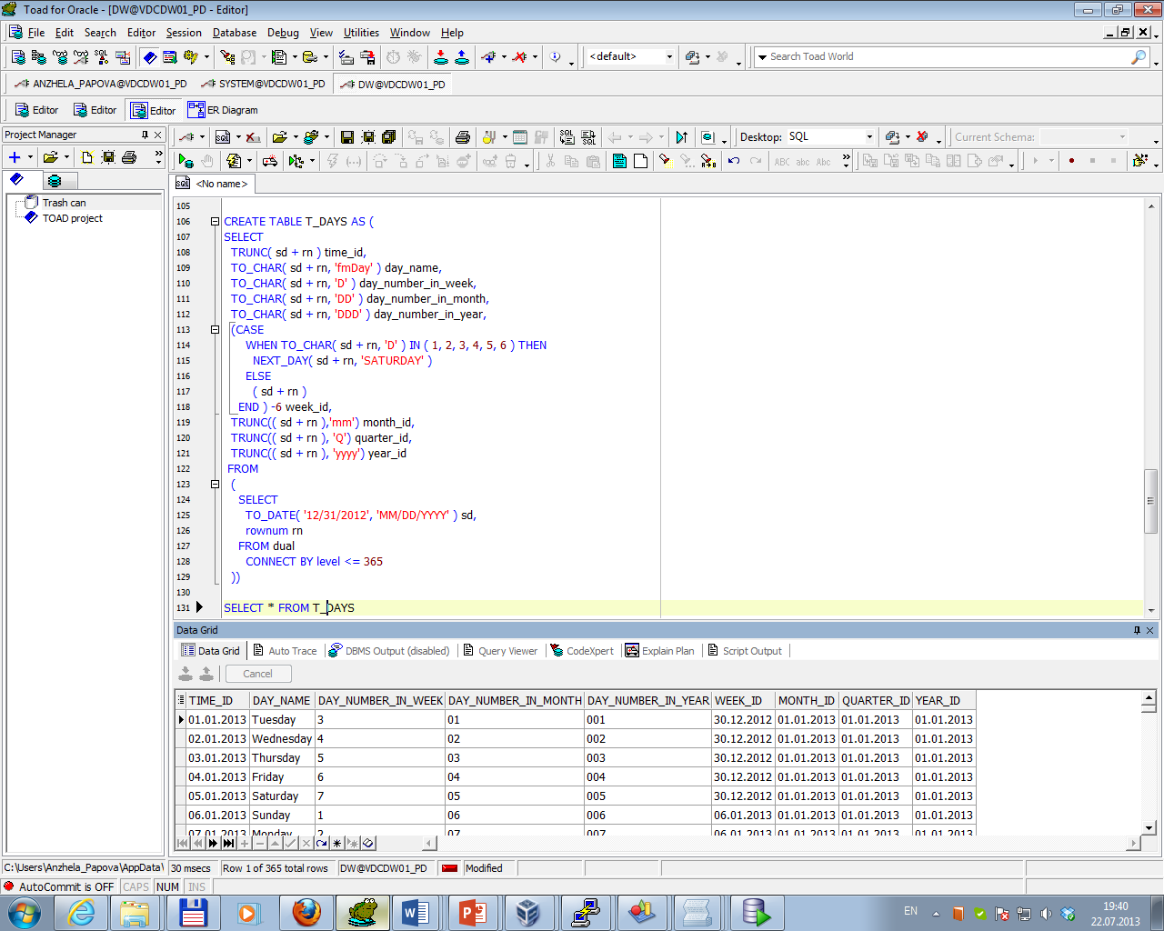

Task 02 CREATE DW.T_WEEKS

Table T_WEEKS was created by running command (attached file T_WEEKS.sql). The result of command execution is presented below.

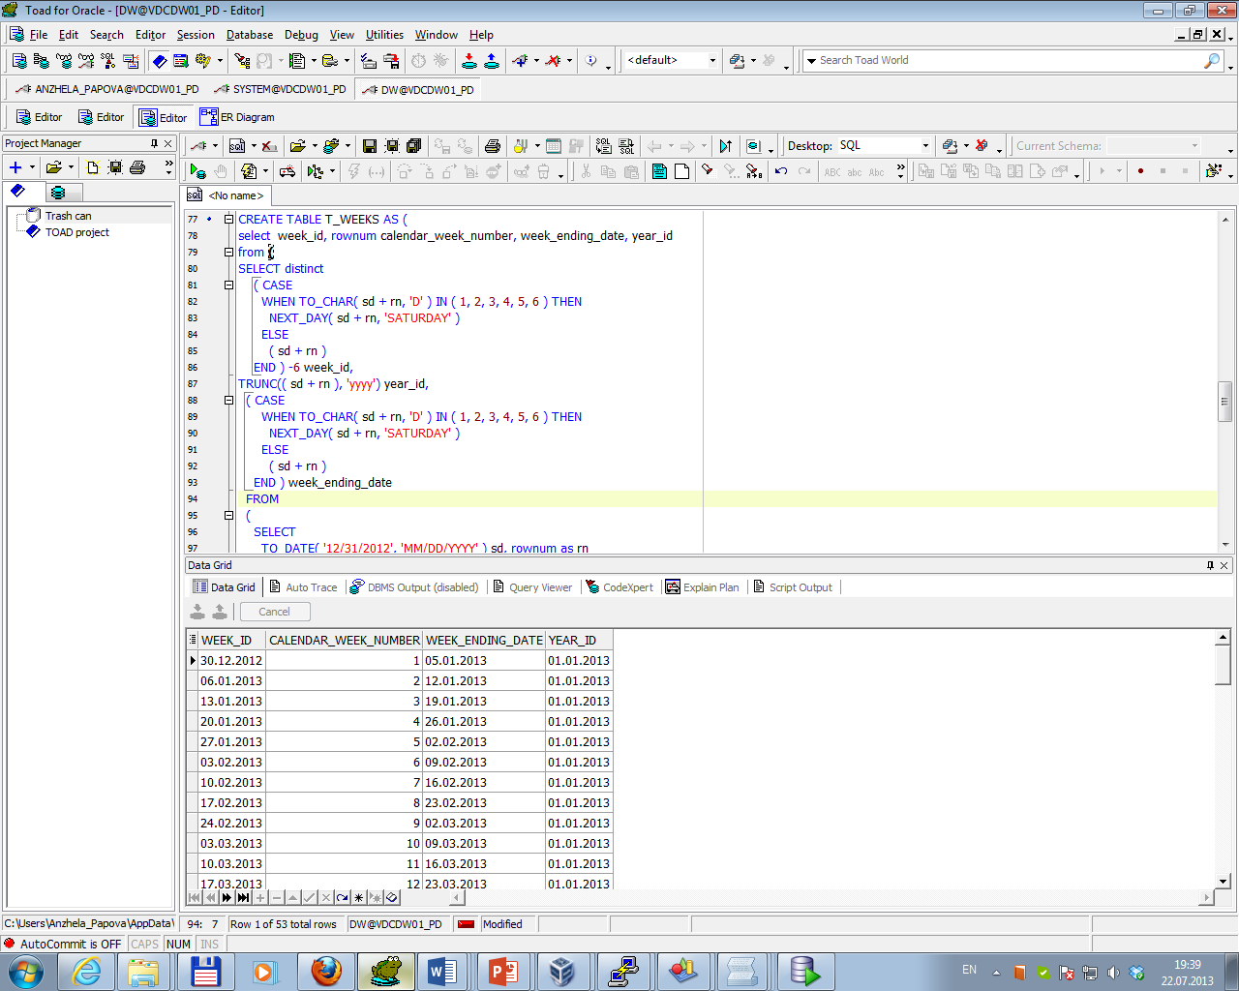

Task 03 CREATE DW.T_MONTHS

Table T_MONTHS was created by running command (attached file T_MONTHS.sql). The result of command execution is presented below.

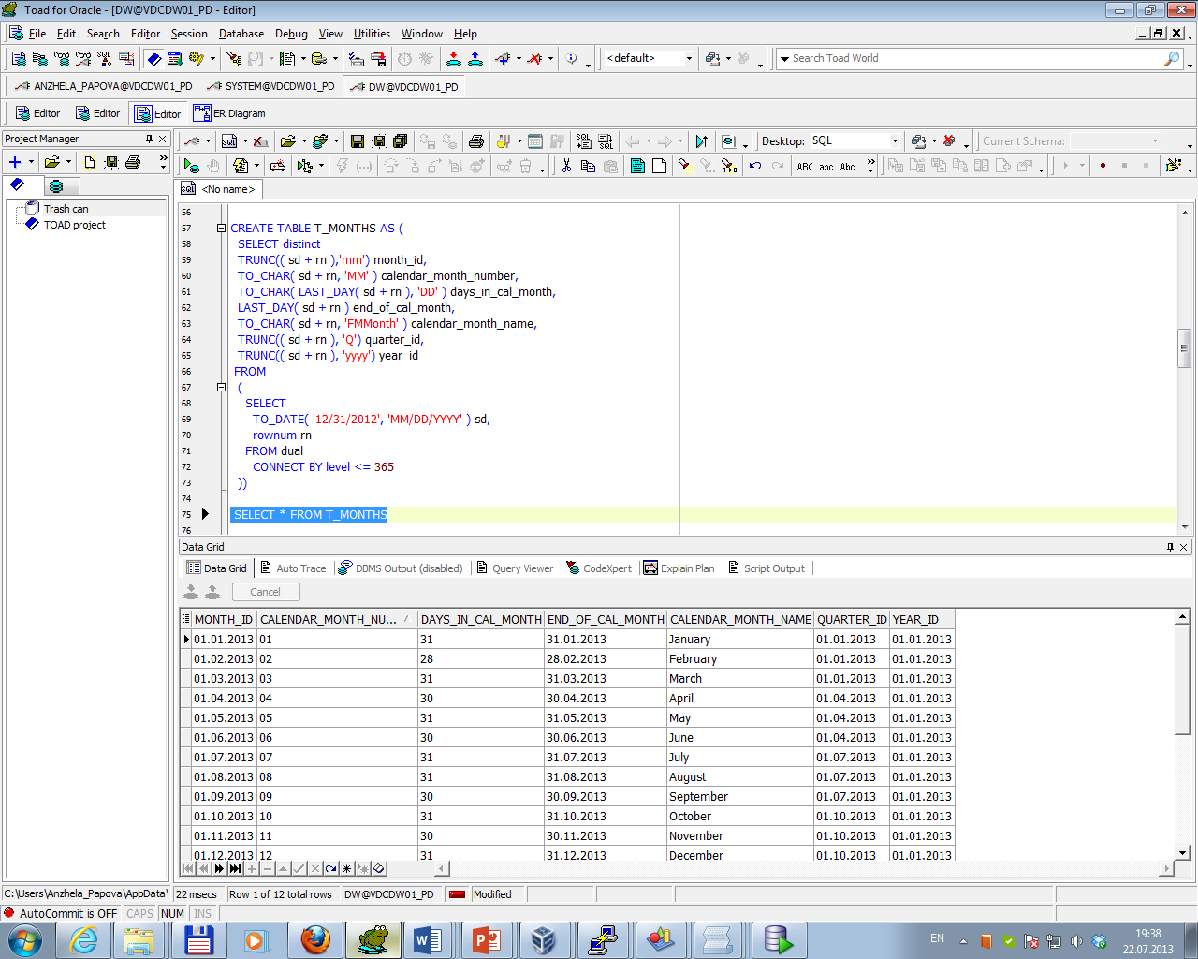

Task 04 CREATE DW.T_QUARTERS

Table T_QUARTERS was created by running command (attached file T_QUARTERS.sql). The result of command execution is presented below.

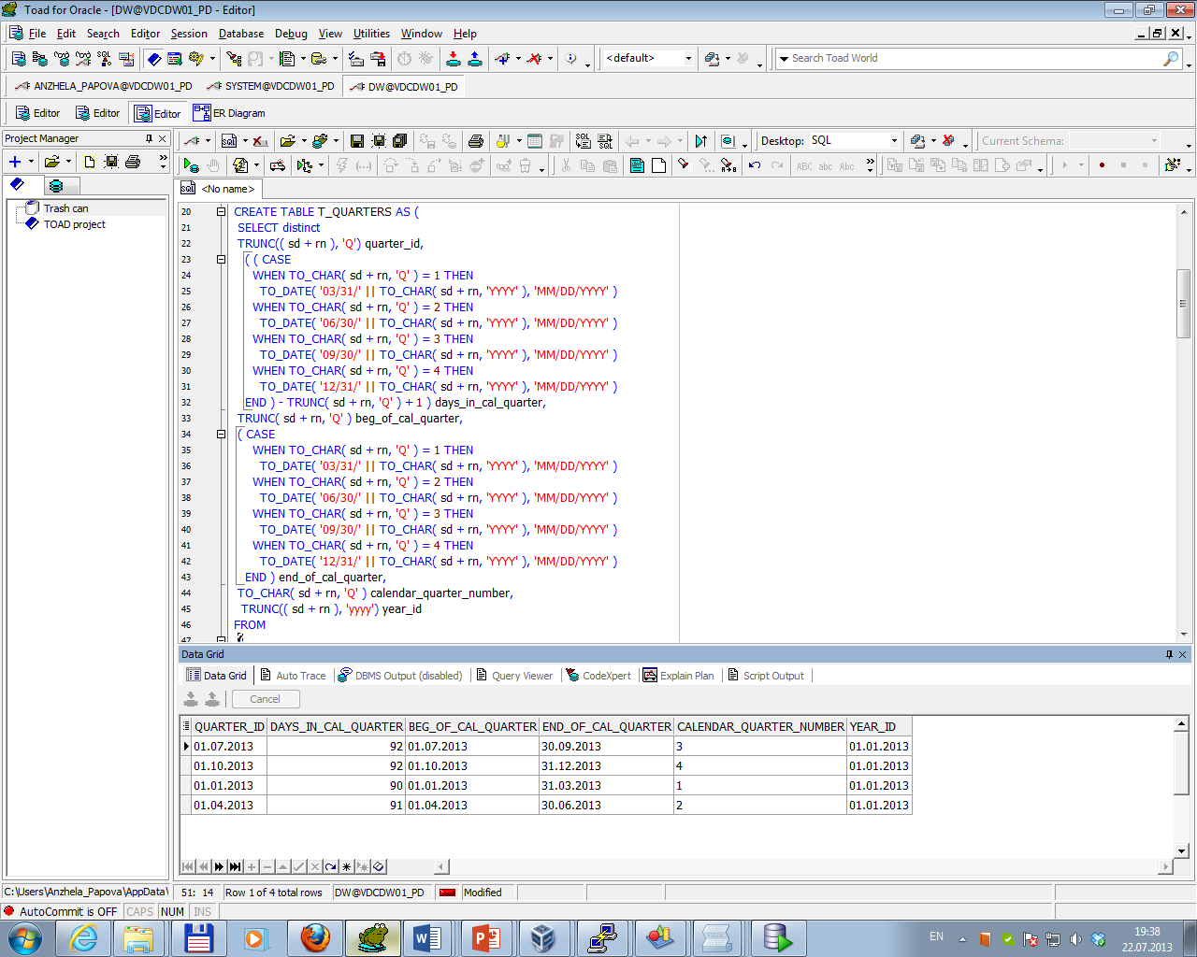

Task 05 CREATE DW.T_YEARS

Table T_YEARS was created by running command (attached file T_YEARS.sql). The result of command execution is presented below.

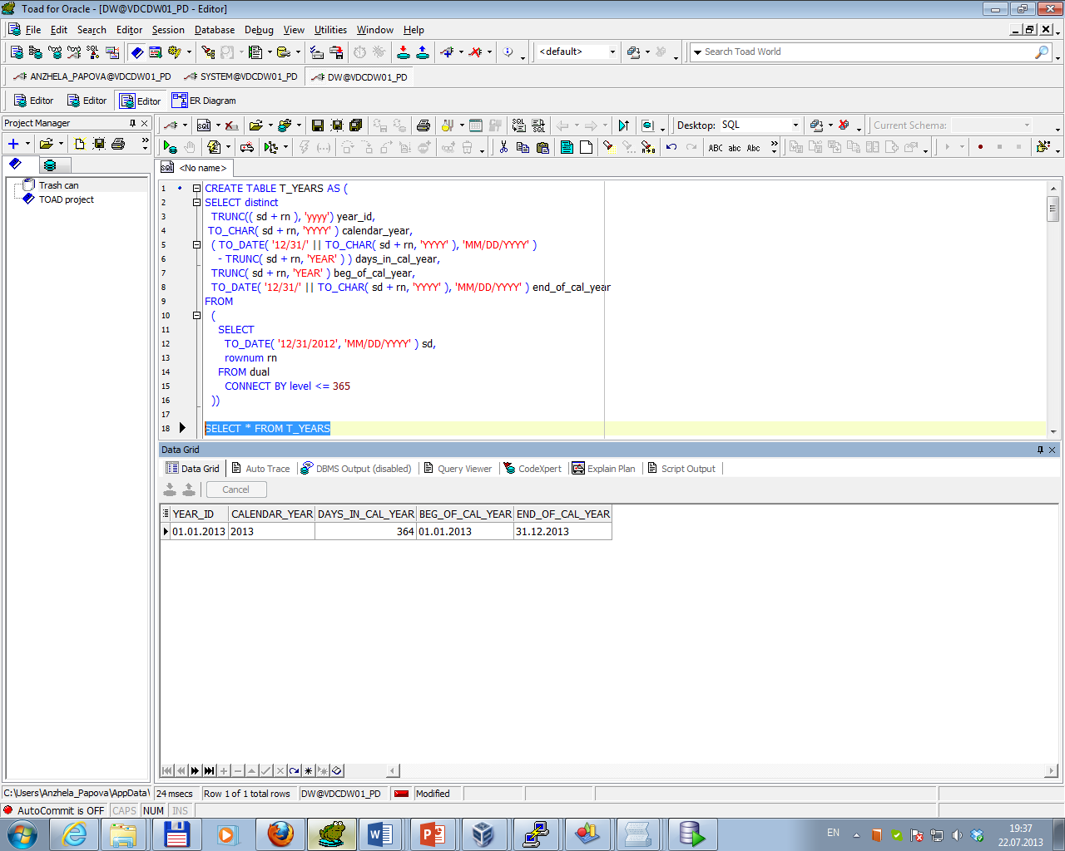

Physical diagram which contained objects and relationships between them is presented below.

